|  |
| --- |
| IT Tralee |
| Project Assignment 2 |
| LifeScan App |
|  |
| **Aidan O'Connor Student No: t00095576** |
|  |

|  |
| --- |
|  |

## Overview

My mobile application is a QR code generator app. I feel the main reason for generating a QR code is to provide valuable information for the person scanning the code. Instead of generating QR codes for advertisements or marketing purposes, this application would be geared towards providing medical information about the user in the case of an emergency or life threating situation.

The application would allow the user to generate a QR code when all of the user’s personal & medical information is filled in. The user would then be allowed to save the QR code image to the gallery on their mobile device therefore allowing them to print the QR code or save the image as their lock screen.

The practical use for this application would be for example if someone fell ill and was unable to communicate with emergency services or medical personnel, the QR code this app generated could be scanned by a paramedic or the person providing medical attention provided the QR code was printed or set as the wallpaper on the injured person’s mobile device. This can be important as a paramedic can discover what allergies or medications the user is taking as well as other information thereby saving valuable time and proving better emergency care.

## LifeScan Application

There are different types of information this app would need the user to fill out in order for the QR code to be generated. These can be categorised by:

* Personal Details
* Contact Details
* Medical Information
* Emergency Contacts
* User’s Hospital Details
* User’s GP Information
* User’s Pharmacy Information
* Health Insurance information

## Whiteboard Diagram

**Home Screen - Login**

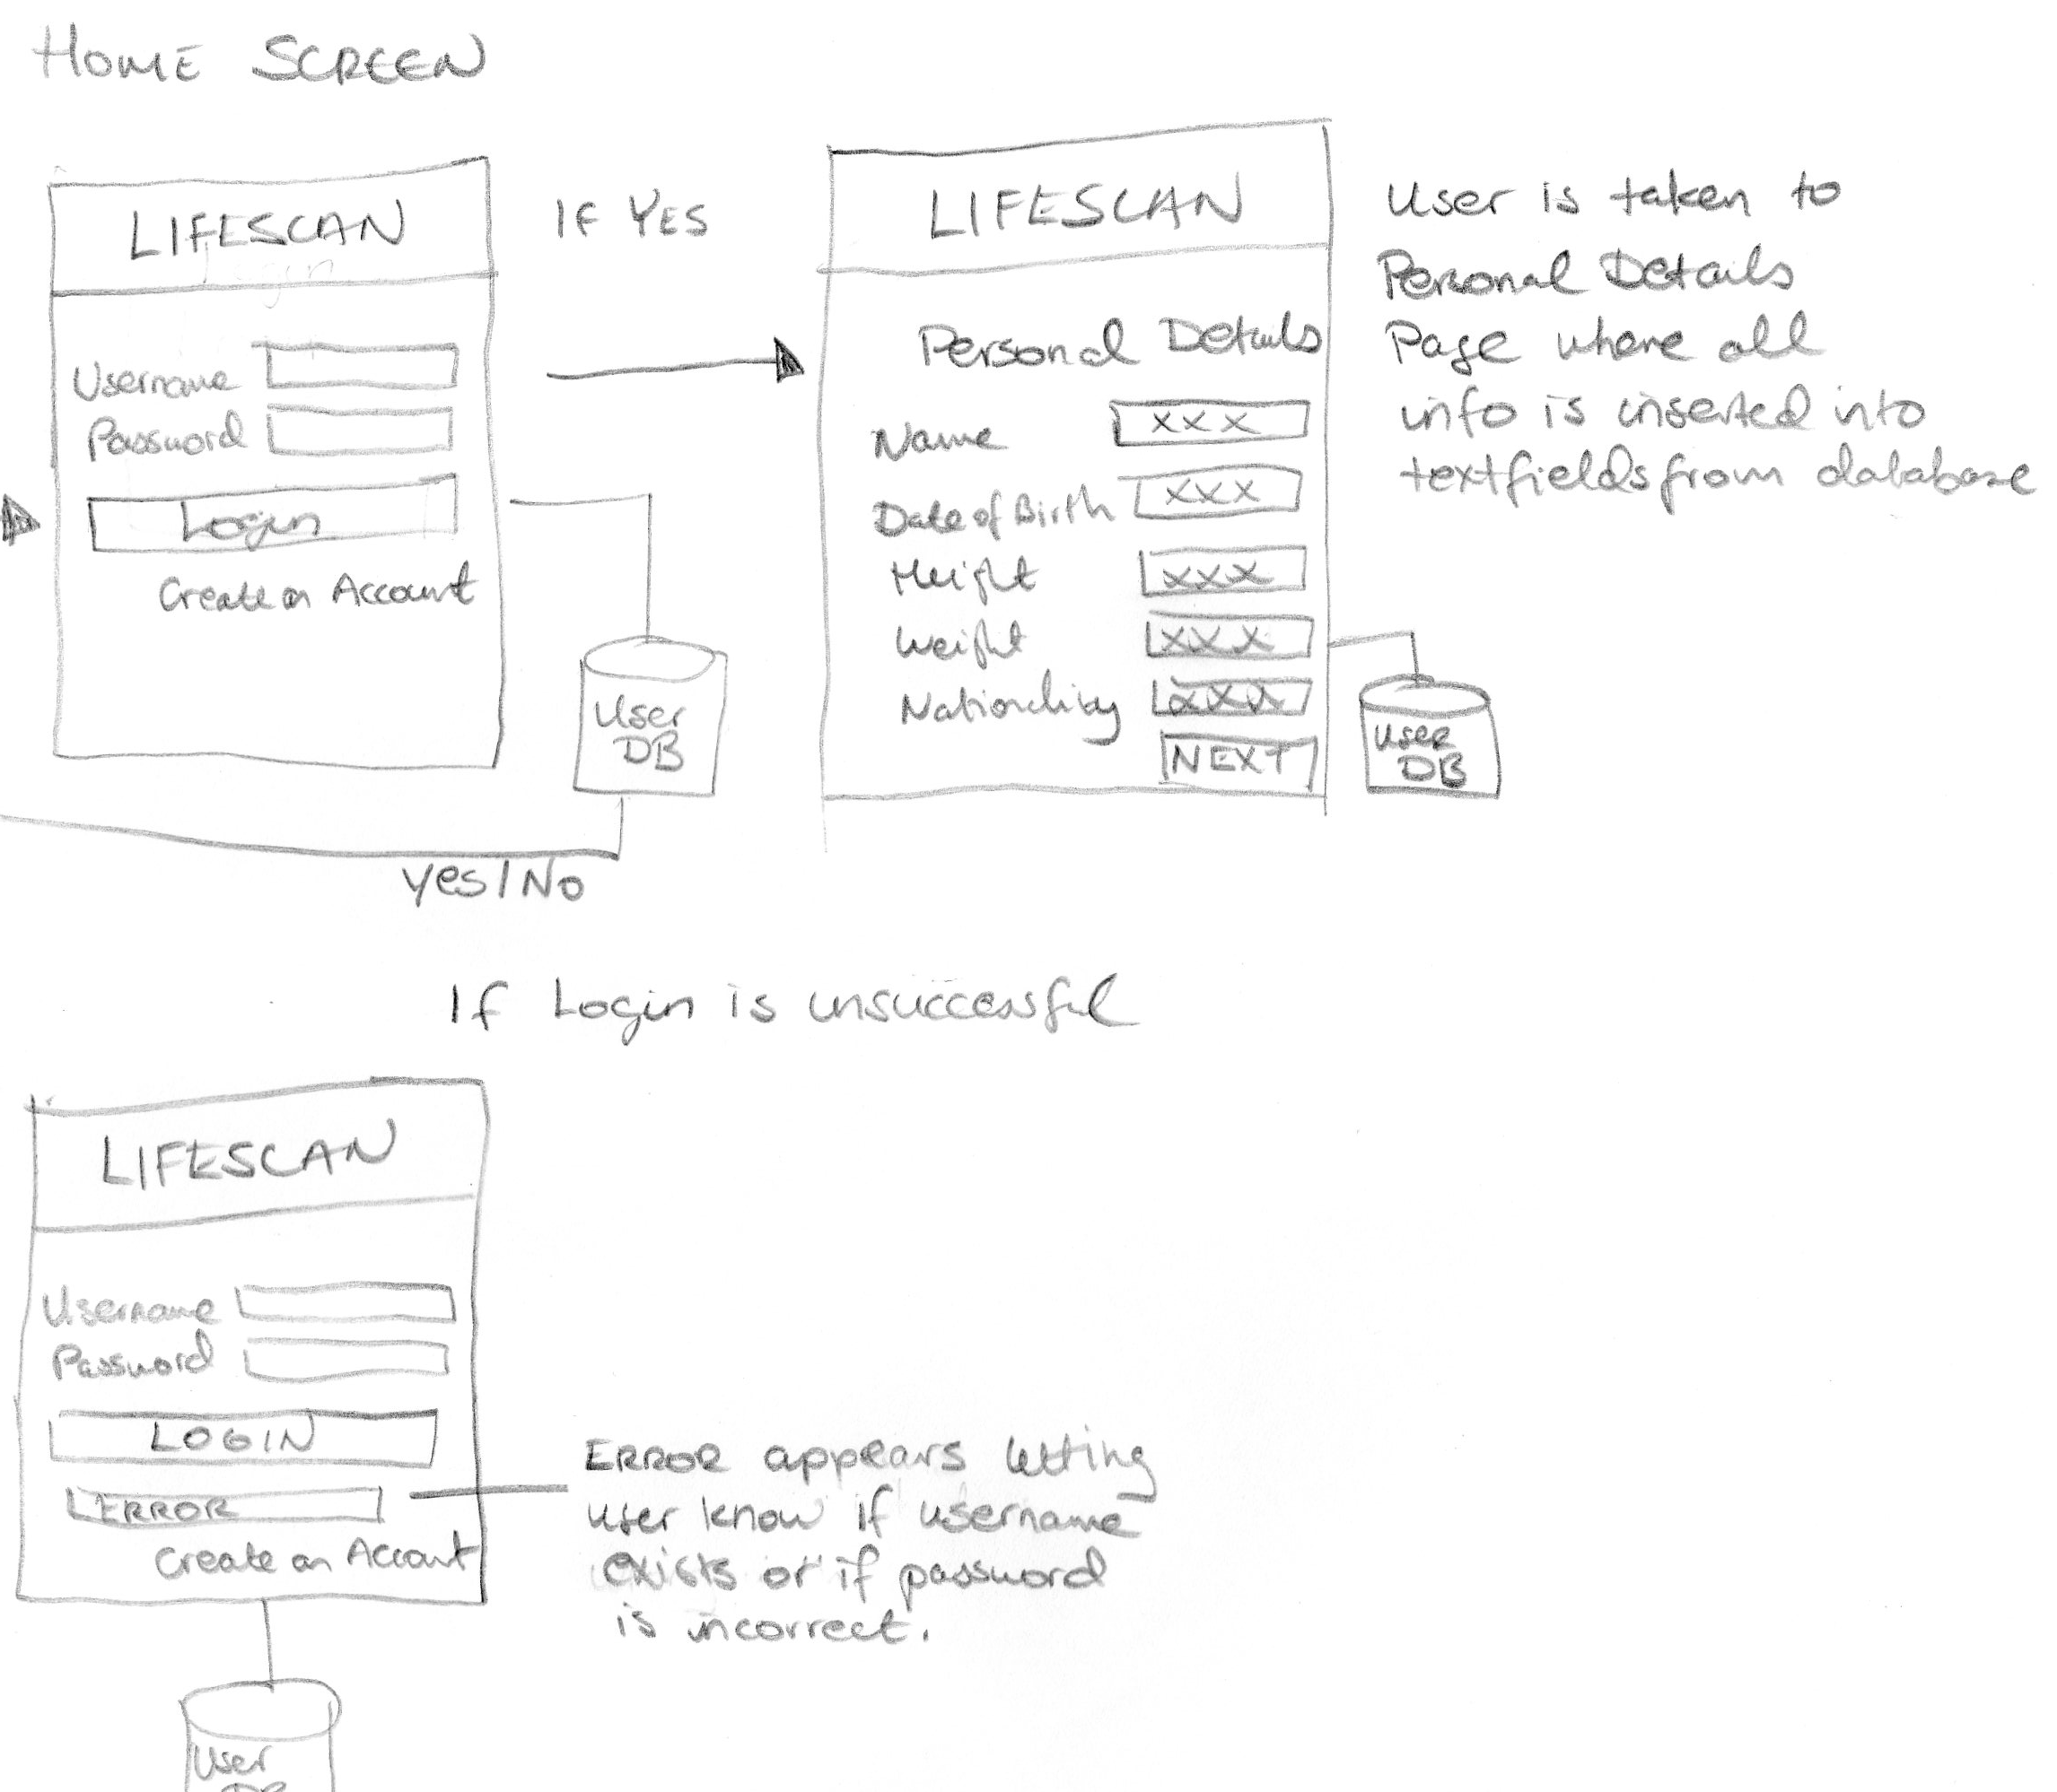

**Create an Account**

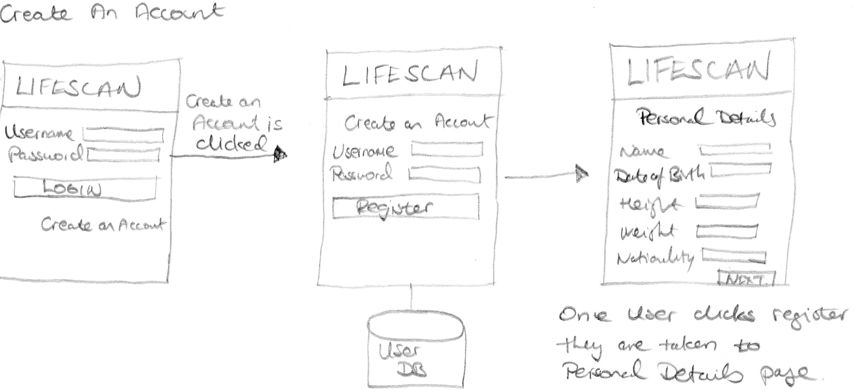

**Flow of Events**

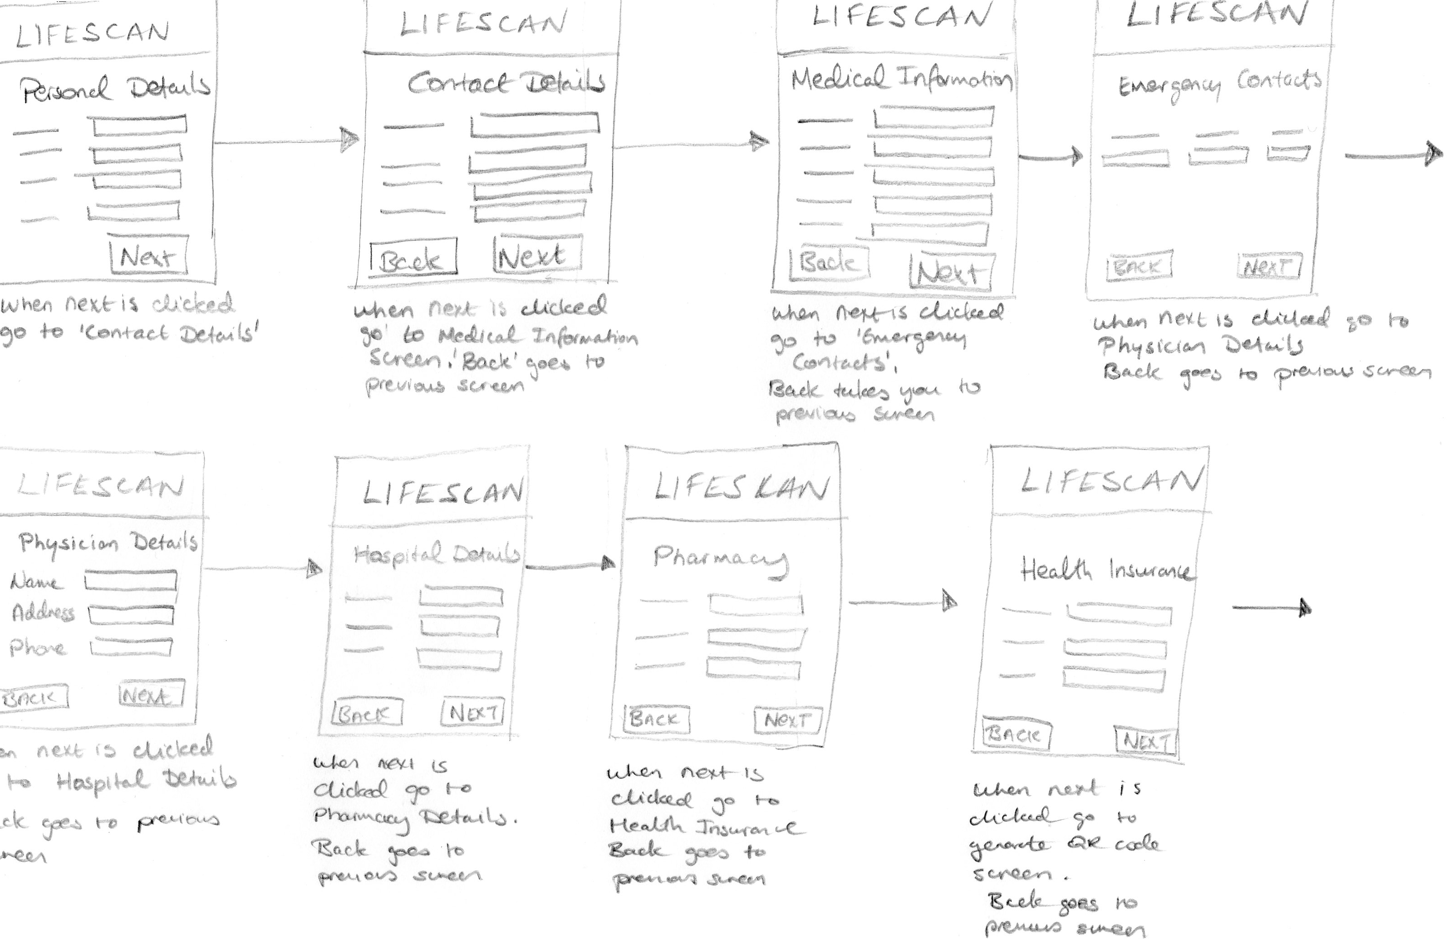

**Generate QR Screen**

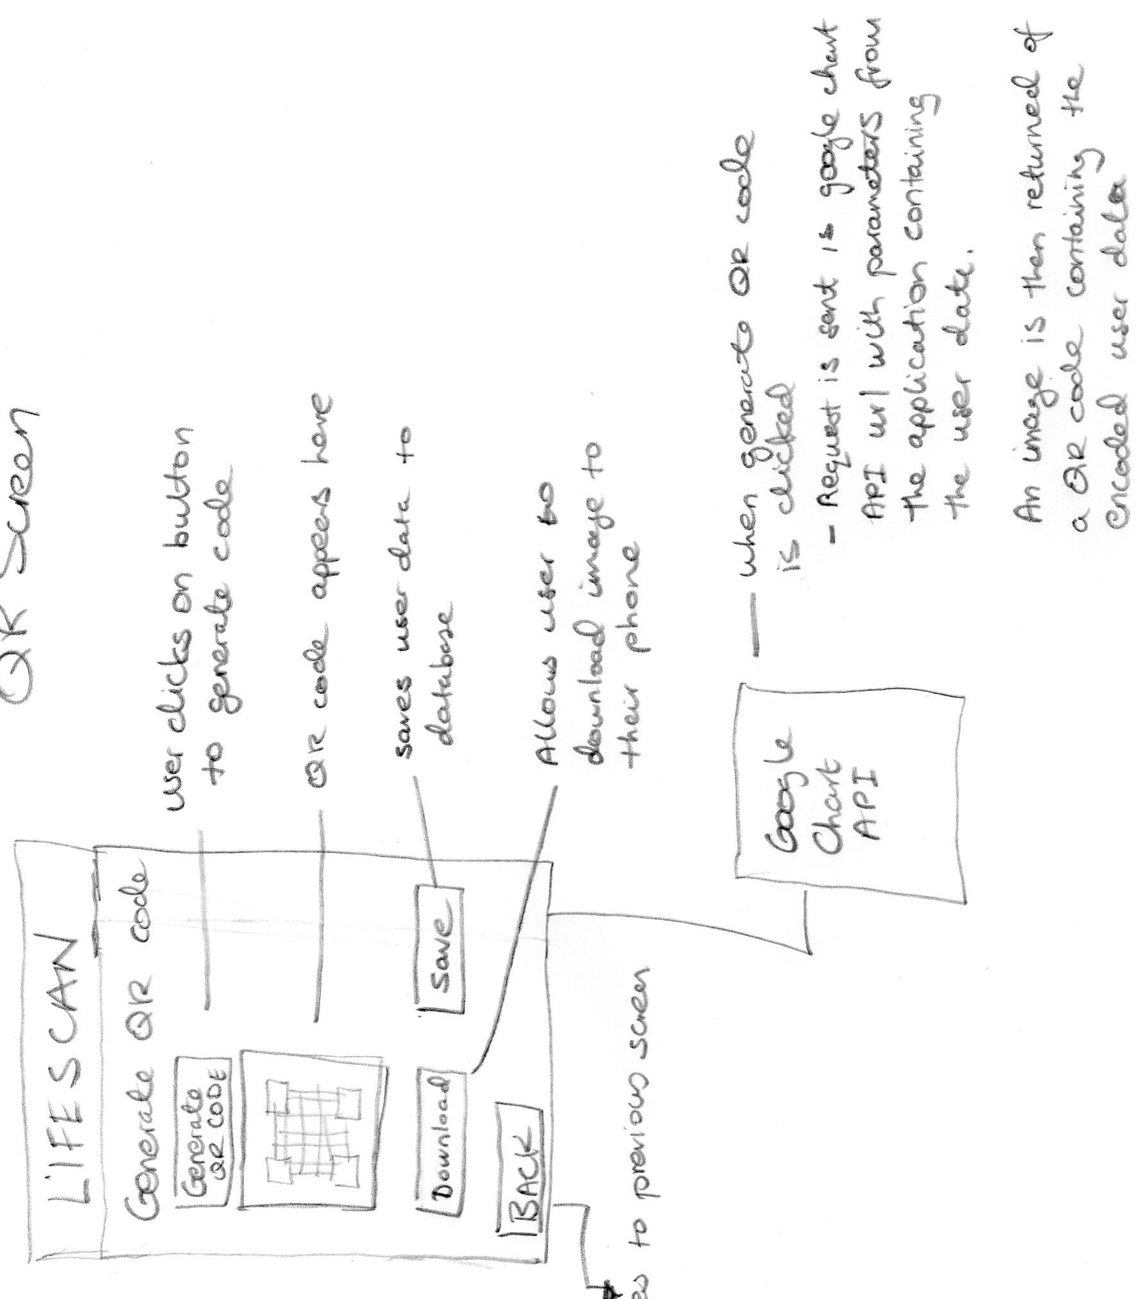

# Prototype

Before working on the implementation a prototype was designed using MIT app inventor.

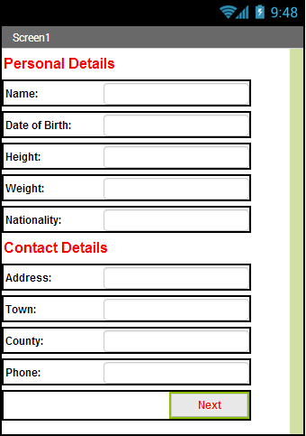

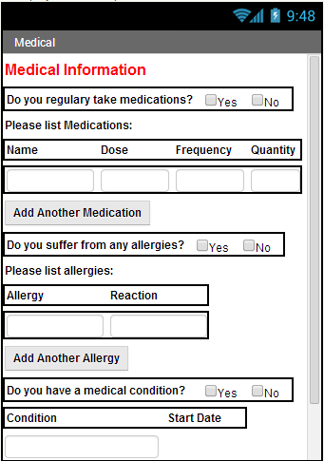

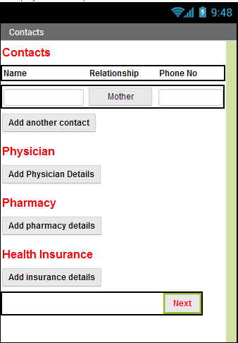

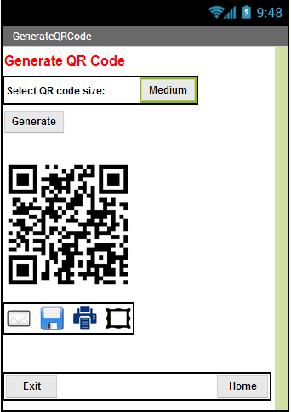

## Pseudo Code

Pseudo-code for each possible interaction for each screen

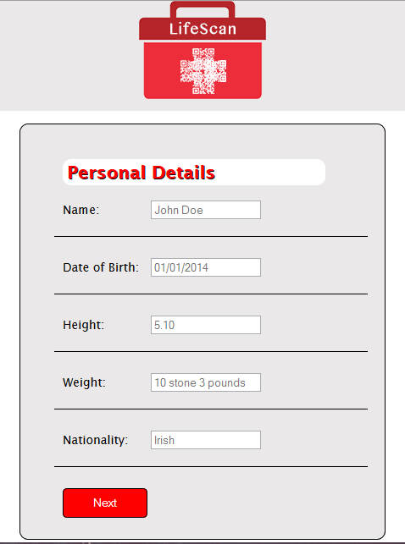

IF Next button is clicked:

CALL FUNCTION Validate Personal Details to check if a text field is NULL

IF a text field is NULL

Alert user which text field they need to fill in

ELSE

Display Contact Details Screen

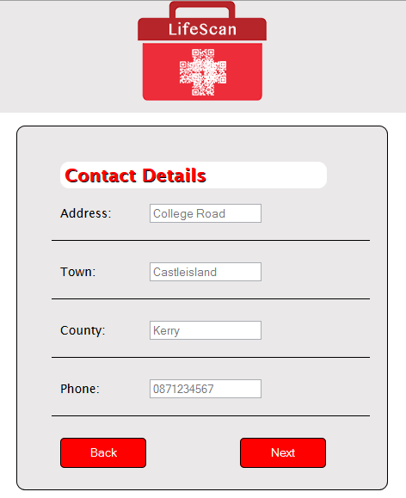

IF Next button is clicked:

CALL FUNCTION Validate Contact Details to check if a text field is NULL

IF a text field is NULL

Alert user which text field they need to fill in

ELSE

CALL FUNCTION to display Medical Information Screen

IF Back button is clicked

CALL FUNCTION Back to Personal Details:

SET Contact Details screen to hidden

SET Personal Details Screen to display

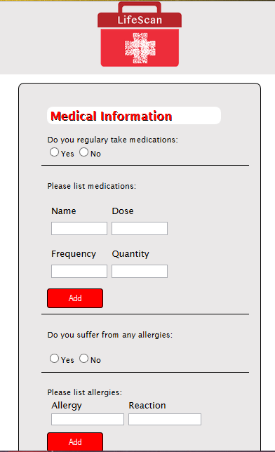

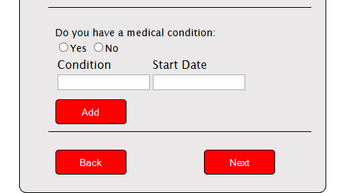

IF Next button is clicked:

CALL FUNCTION Validate Medical Information to check if a text field is NULL

IF a text field is NULL

Alert user which text field they need to fill in

ELSE

CALL FUNCTIONS Get Medication List, Allergy List, Medical Condition List

FOR LOOP through each array and RETURN results

CALL FUNCTION to display Emergency Contacts Screen

IF Back button is clicked

CALL FUNCTION Back to Medical Information:

SET Medical Information Screen to hidden

SET Emergency Contacts screen to display

IF ADD Medication is clicked:

Append 2 columns and 2 Rows to medications table

IF ADD Allergy is clicked:

Append a row and two columns to allergies table

IF ADD Medical Condition clicked:

Append a row and two columns to medical conditions table

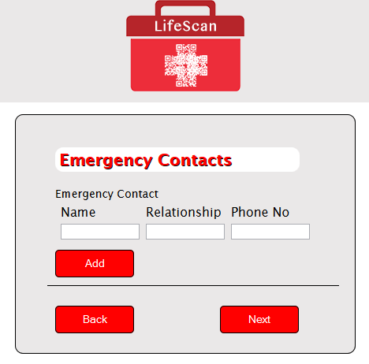

IF Next button is clicked:

CALL Function Validate Emergency Contact Details to check if a text field is NULL

IF a text field is NULL

Alert user which text field they need to fill in

ELSE

CALL FUNCTION Get Emergency Contacts List

FOR LOOP through the array and RETURN results

CALL FUNCTION to display Physician Details Screen

IF Back button is clicked

CALL FUNCTION Back to Medical Information:

SET Emergency Contacts Details screen to hidden

SET Medical Information Screen to display

IF ADD is clicked:

Append a row and three columns to emergency contact table

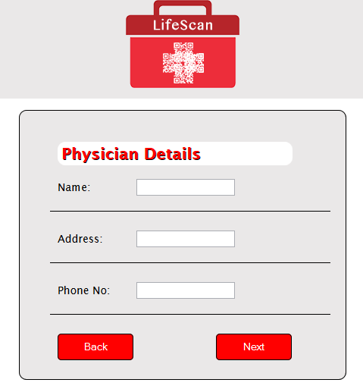

IF Next button is clicked:

CALL FUNCTION Validate Physician Details to check if a text field is NULL

IF a text field is NULL

Alert user which text field they need to fill in

ELSE

Call function to display Hospital Details Screen

IF Back button is clicked

CALL FUNCTION Back to Emergency Contacts:

SET Physician Details screen to hidden

SET Emergency Contacts screen to display

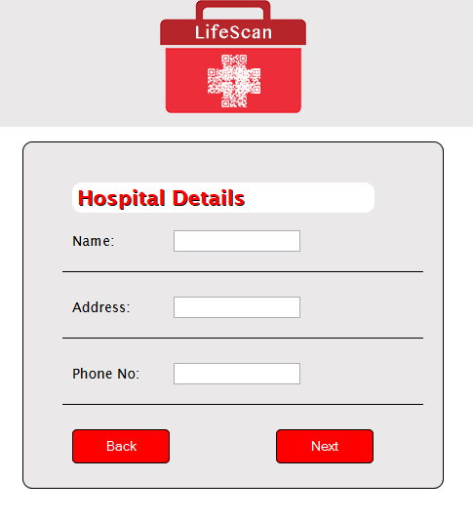

IF Next button is clicked:

CALL FUNCTION Validate Hospital Details to check if a text field is NULL

IF a text field is NULL

Alert user which text field they need to fill in

ELSE

CALL FUNCTION to display Pharmacy Details Screen

IF Back button is clicked

CALL FUNCTION Back to Physician Details:

SET Hospital Details screen to hidden

SET Physician Detail screen to display

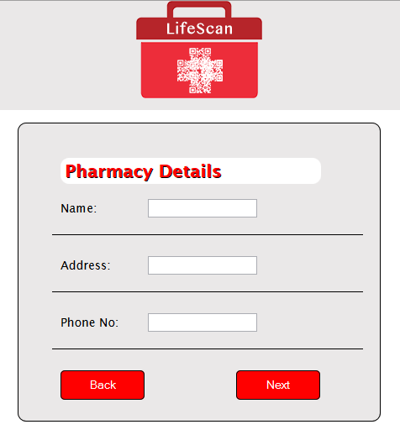

IF Next button is clicked:

CALL FUNCTION Validate Pharmacy Details to check if a text field is NULL

IF a text field is NULL

Alert user which text field they need to fill in

ELSE

CALL FUNCTION to display Health Insurance Details Screen

IF Back button is clicked

CALL FUNCTION Back to Physician Details:

SET Pharmacy Details screen to hidden

SET Hospital Details screen to display

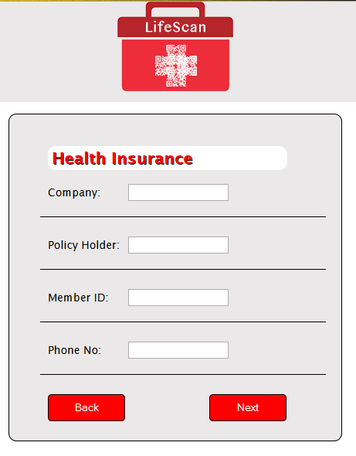

IF Next button is clicked:

CALL FUNCTION Validate Health Insurance Details to check if a text field is NULL

IF a text field is NULL

Alert user which text field they need to fill in

ELSE

CALL FUNCTION to display Generate QR Code Screen

IF Back button is clicked

CALL FUNCTION Back to Pharmacy Details:

SET Health Insurance Details screen to hidden

SET Pharmacy Details screen to display

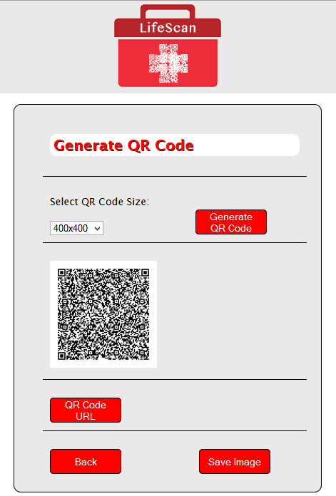

IF Generate QR code button is clicked:

CALL FUNCTION Generate QR code:

SET variable QRText to text field values user has entered

SET Image Size to selected user value

Append QRText and Image Size to Google chart URL

SET QR image attribute to Google chart URL

IF Back button is clicked

CALL FUNCTION Back to Health Insurance Details:

SET Generate QR Code screen to hidden

SET Health Insurance Details screen to display

# Database Schema

### Database Name

UsersDb – stores all users data

### Database Keys & Values

The username that the user registers with will be appended to each key to replace the term user.

**Key Value**

user_username username

user_password password

**Personal Details**

user_fullName users full name

user_date_of_birth date of birth

user_height height

user_weight weight

user_nationality nationailty

**Contact Details**

user_address address

user_town town

user_county county

user_telephone phone number

**Medical Information**

user_medication medication name

user_medication_dose medication dose

user_medication_frequency frequency of use

user_medication_quantity user medication quantity

user_allergy allergy

user_allergy_reaction reaction

user_medical_condition medical condition

user_medical_condition_start_date medical condition start date

**Emergency Contacts**

user_emergency_contact_name emergency contact name

user_emergency_contact_relationship relationship to emergency contact

user_emergency_contact_phone emergency contact phone number

**Physician Details**

user_physician_name physician name

user_physician_address physician address

user_physician_phone physician phone

**Pharmacy Details**

user_pharmacy_name pharmacy name

user_pharmacy_address pharmacy address

user_pharmacy_phone pharmacy phone number

**Hospital Details**

user_hospital_name hospital

user_hospital_address hospital address

user_hospital_phone hospital phone number

**Health Insurance Details**

user_insurance_company insurance company name

user_insurance_holder insurance policy holder

user_insurance_member_id member id

user_insurance_insurance_phone insurance company phone number